



**YEAR 12 CHEMISTRY**

**ORGANIC CHEMISTRY TEST**

**ANSWERS**

This test consists of three sections

Section one: 20 Multiple choice questions (20 marks)

Section two: 5 Short answer questions (20 marks)

Section three: 1 Extended answer question (10 marks)

Recommended time: 50 minutes

Please:

Do not open the test papers until instructed

Do not write in the multiple choice question paper.

MULTI-CHOICE ANSWER SHEET

Use a blue or black biro to mark the correct answer by shading over the letter (eg. B)

If you change your mind, shade over the letter for the revised correct answer (as above) and place a cross over the deleted answer (eg. C ).

|  |  |  |  |  |  |  |  |  |  |  |  |  |
| --- | --- | --- | --- | --- | --- | --- | --- | --- | --- | --- | --- | --- |
|  |  |  |  |  |  |  |  |  |  |  |  |  |
|  |  |  |  |  |  |  |  |  |  |  |  |  |
| 1 | A | B | **C** | D |  |  |  |  |  |  |  |  |
| 2 | A | B | C | **D** |  |  |  |  |  |  |  |  |
| 3 | A | **B** | C | D |  |  |  |  |  |  |  |  |
| 4 | A | **B** | C | D |  |  |  |  |  |  |  |  |
| 5 | A | **B** | C | D |  |  |  |  |  |  |  |  |
| 6 | A | **B** | C | D |  |  |  |  |  |  |  |  |
| 7 | A | B | C | **D** |  |  |  |  |  |  |  |  |
| 8 | A | B | C | **D** |  |  |  |  |  |  |  |  |
| 9 | A | B | C | **D** |  |  |  |  |  |  |  |  |
| 10 | A | **B** | C | D |  |  |  |  |  |  |  |  |
| 11 | A | B | C | **D** |  |  |  |  |  |  |  |  |
| 12 | A | **B** | C | D |  |  |  |  |  |  |  |  |
| 13 | A | B | C | **D** |  |  |  |  |  |  |  |  |
| 14 | **A** | B | C | D |  |  |  |  |  |  |  |  |
| 15 | A | **B** | C | D |  |  |  |  |  |  |  |  |
| 16 | **A** | B | C | D |  |  |  |  |  |  |  |  |
| 17 | A | B | C | **D** |  |  |  |  |  |  |  |  |
| 18 | **A** | B | C | D |  |  |  |  |  |  |  |  |
| 19 | **A** | B | C | D |  |  |  |  |  |  |  |  |
| 20 | A | **B** | C | D |  |  |  |  |  |  |  |  |
|  |  |  |  |  |  |  |  |  |  |  |  |  |

You may use the space for rough working for multi-choice questions

**Section 2: Short Answer.** This section is worth **20 marks**

Answer in the spaces provided.

21. Complete the table below by giving a brief description of a chemical test that could be used

to distinguish between the substances listed.

List the observations relating to the test for each of Substance 1 and Substance 2.

|  |  |  |
| --- | --- | --- |
|  | Description of chemical test | Observation  with substance 1 |
| Substance 1  butan-2-one |  |  |
| Substance 2  Butanal | Observation with substance 2 |
|  |

|  |  |
| --- | --- |
| Description | Mark |
| Addition of acidified oxidising agent | 1 |
| Observation for Substance 1 – no visible change | 1 |
| Observation for Substance 2 – must state original and final colour  i.e. permanganate purple to colourless  dichromate orange to green | 1 |
| Total | 3 |

22. Draw the structural formulae for the following:

1. Three (3) structural (positional) isomers of the compound that has the molecular formula C5H10. Show all of the atoms in the structure.









|  |  |
| --- | --- |
| Description | Mark |
| Any of the 3 structures | 3 |
| Correct structure but missing H or H drawn as I deduct 1 mark | 2 |
| Total | 3 |

(b) Two geometric isomers of the compound that has the molecular formula C5H10







|  |  |
| --- | --- |
| Description | Mark |
| Correctly drawn structures 1 mark each | 2 |
| Correct structure but missing H or H drawn as I deduct 1 mark | 1 |
| Total | 2 |

(2 marks)

1. A compound is known to be an ester. Its molar mass is 74. 0 g mol-1. Draw two structural

isomers of this compound





|  |  |
| --- | --- |
| Description | Mark |
| Correctly drawn structures 1 mark each | 2 |
| Correct structure but missing H or H drawn as I deduct 1 mark | 1 |
| Total | 2 |

23 Explain why butanoic acid is a solid at room temperature whereas methyl propanoate is a liquid at room temperature. Include simple diagrams in your answer.



-

+

Butanoic acid





+

-

H=Bonding and dipole -dipole

Methyl propanoate

-

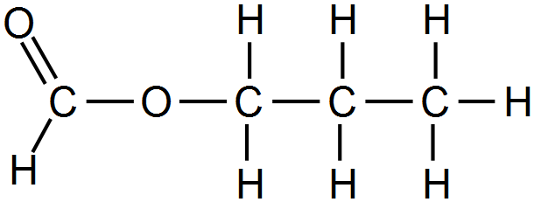

Dipole – diploe interaction at carbonyl group

+

|  |  |
| --- | --- |
| Description | Mark |
| Correctly drawn structures showing dipoles and names of bonding type | 2 |
| Correctly drawn structures without showing dipoles but correctly named bonding type | 1 |
| Explanation based on butanoic acid has stronger intermolecular forces due to both H – bonding and dipole-dipole (or 2 sites for H-bonding) while methyl propanoate has only dipole-dipole. | 1 |
| Total | 3 |

24 Complete the table below by either naming the compound whose structural formula has been given

or using the name of the compound that is given draw the compounds structural formula.

|  |  |
| --- | --- |
| Name | Structural formula |
| 2-methylbutanal |  |
| 2-ethylbutanamine |  |
| Trans-4-methylpent-2-ene |  |
| pentanamide |  |

|  |  |
| --- | --- |
| Description | Mark |
| Correctly drawn structures 1 mark each | 4 |
| Correct structure but missing H or H drawn as I deduct 1 mark | 3 |
| Total | 4 |

25. Kevlar is the registered [trademark](https://en.wikipedia.org/wiki/Trademark) for a polyamide that has a high tensile strength to weight ratio, far exceeding steel. It is used in “bullet proof jackets” but is more widely used in aerospace engineering.

The monomers used to make Kevlar are

 and 

Draw the polymer that forms when these two monomers react to form a polymer. Include two repeating units in your diagram

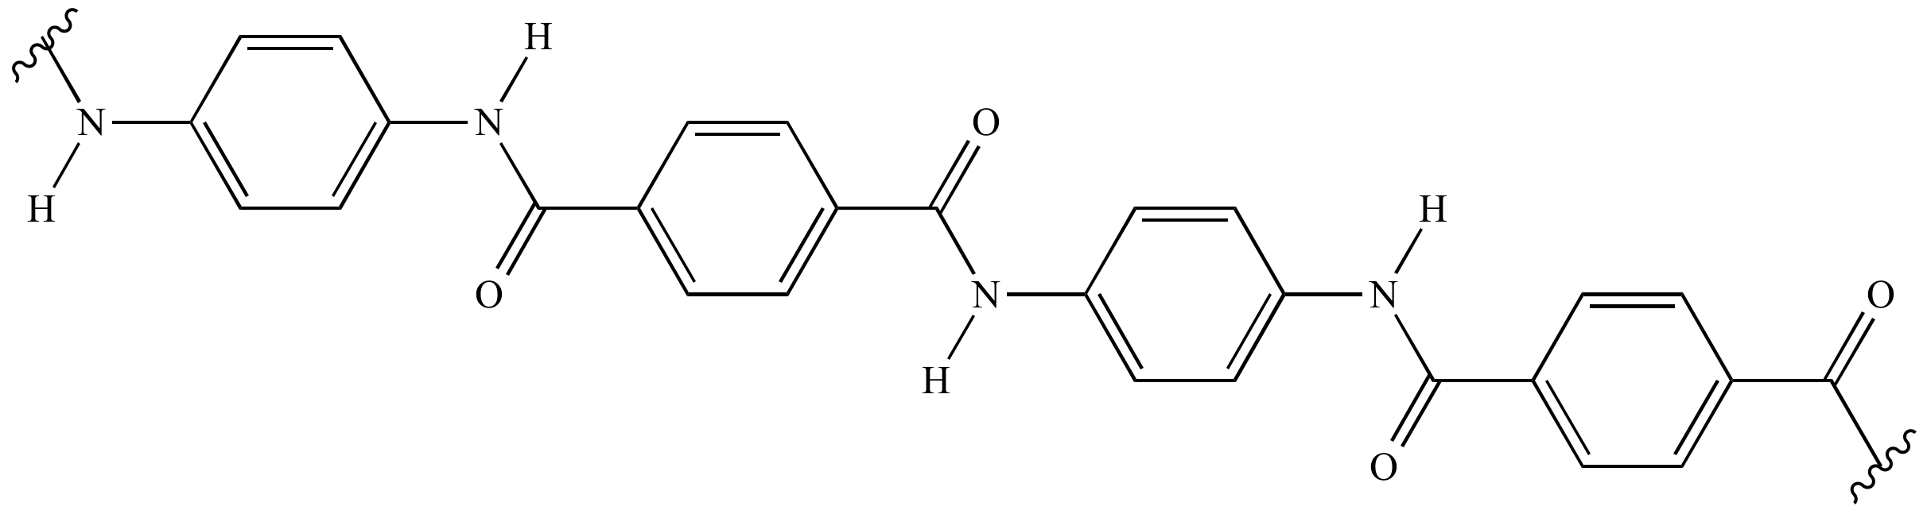

|  |  |
| --- | --- |
| Description | Mark |
| Two repeating groups showing terminal carboxyl and amino terminal groups | 3 |
| Correct polymer but has amine (NH2) and carboxylate (COOH) ends drawn deduct 1 mark | 2 |
| Total | 3 |

**Section 3 Extended answer.**

Qualitative analysis of the compound responsible for the unpleasant smell of rancid butter showed it to contain carbon, hydrogen and oxygen. A sample of the compound has a mass of 0.392g and a gaseous volume of 152 mL at 170 °C and 105k Pa. This sample was mixed with excess oxygen and the mixture was sparked. The products of the reaction were 0.320 g of water and 405 mL of carbon dioxide measured at 27.1 °C and 110 kPa. From these results determine:

1. the masses of carbon, hydrogen and oxygen in the sample.
2. the empirical formula of the compound.
3. the molecular mass of the compound.
4. the molecular formula of the compound
5. This compound is extremely soluble in water and will not react with an acidified oxidizing agent. Given this information draw a possible structural formula for the compound and give its IUPAC name.

|  |  |
| --- | --- |
| Description | Marks |
| Moles of H2O = 0.320 = 1.776 x 10-2  18.016  Moles H atoms = 2 x 1.776 x 10-2 = 3.552 x 10-2 moles. | 1 |
| Mass of H atoms = 3.552 x10-2 x 1.008 = 0.0358 g | 1 |
| Moles of CO2 = PV = 110 x 0.405 = 1.784 x 10-2 moles  RT 8.314(273.15+ 27.1)    Mass of C atoms = 1.784 x 10-2 x 12.01 = 2.143 g | 1 |
| Mass of O atoms = 0.392 – (2.143 + 0.0358 ) = 0.1422 g  Moles of O atoms = 0.1422 ÷ 16 = 8.88 x 10-3 | 1 |
| C H O  Moles 1.784 x 10-2 3.552 x 10-2 8.88 x 10-3  Mole ratio 2.00 3.99 1 | 1 |
| Empirical Formula C2H40  Empirical mass = 44.052 | 1 |
| Molecular Formula  Moles of sample in = PV = 105 x 0.152 = 4.332 x 10-3  0.392 g RT 8.314 x (273.15 +170)  Molar mass = 0.392 = 90.49  4.332 x 10-3 | 1 |
| Ratio Molar mass = 90.49 = 2.05  Empirical mass 44.052  Molecular Formula C4H8O2 | 1 |
| Correctly drawn and named compound      utanoic  OR  2- methylpropanoic acid  Butanoic acid | 2 |
| Total | 10 |